Who Cares About Science?

# A statistical analysis on public sentiment regarding federal science research spending.

Jacob Holman, M.S. Statistics, California State University, East Bay

Ignacio Faria, M.S. Statistics, California State University, East Bay

### 12/1/2016

## Abstract

Federal funding for NASA (9) and the EPA (11) are decreasing, and it appears that people do not care for science nor the contributions it makes to society. What is it that makes voters apathetic towards the continual decrease in funding in these departments? Gathering data from the GSS, we used demographic characteristics and religious opinions to model voter sentiments regarding federal funding in science, space research, and environmental protection and improvement. Surprisingly, differences in gender, race, education, political ideology, level of belief in God, and degree of fundamentalism were significant in predicting an individual’s sentiment towards government spending in science, space research, and environmental protection and improvement.

## Introduction

Few aspects of the human experience exceed the need to explore and preserve our lives. In the 1960s, NASA’s space research brought the success of the Apollo missions that left the world in awe as the USA became the most scientifically advanced nation in the world. Today, atmospheric and environmental research has revealed the looming extinction level event of global warming. Scientists are at a consensus on the topic (3), yet climate change deniers represent the voting majority and their attitudes reflect the policies that their politicians enact. Why do they not care? With the continual decrease in funding with NASA and the EPA, it appears that the economic benefit from investing in these departments goes unseen by the general public.

In their perpetual quest for understanding, scientists must always develop further means to investigate the universe, and these means typically have unforeseen economic benefits. Innovations on robotics and shock-absorption have lead to better solutions for human and animal prostheses (2). Grooving in highway roads, rubber for tires, hazardous chemical detection, firefighter gear, enriched baby foods, water purification, and the memory foam commonly used in mattresses are a tiny fraction of the positive side effects of NASA’s research (1). The products that NASA creates sprout business developments that, on average, return $7 to $14 for every dollar invested; a return that few business can boast (4-5). Contrary to public benefit, NASA’s budget has been continually decreasing. With this evidence, why is NASA funding not an American priority?

Most Americans do not experience global warming in their immediate lives, and this makes the gravity of the issue difficult and abstract to understand. Glaciers are retreating more rapidly than ever recorded, and carbon dioxide levels are rising exponential due to fossil fuel emissions. Today, 97% (the lower bound) of publishing climate change experts(7), well as a host of about 200 scientific organizations around the world hold that climate change is happening and due to human activity (6). Considering that evidence, it is surprising that the new presidential administration has appointed an avid climate change denier (with no scientific degree) in charge of the Environmental Protection Agency (12). This administration also plans on repositioning NASA as a space only research organization and cutting its “politically correct environmental monitoring” research on climate change (13). If this is truly the reflection of public sentiment, then why is there such a disregard to the global scientific consensus? Whether it be short term memory loss with NASA’s contributions or short term economic gains by neglecting the environment, it appears that the public’s short sighted perspective on science is short changing the progress that we need to progress and survive as a species. This report will look at the contributing factors regarding federal funding in science, space, and the environment.

## Methods 1 - The Data

The General Social Survey (GSS) is conducted by the National Opinion Research Center at the University of Chicago. This survey measures public attitudes on a massive variety of topics. The data is collected through survey interviews (personal, computer assisted, or telephone) and responses are recorded. The data can be downloaded from http://gss.norc.org/get-the-data/stata and easily translated into the software program called Statistical Analysis Software (SAS). SAS makes it easy to convert the data into csv format, and by doing this, we opened the data in R (another statistical software) to observe and clean it.

### 

### Variables

More important than the public’s attitude about science, space research, and environmental protection, is their opinions on how the government allocates its budget on these departments. The GSS dataset has three particular variables that record just this. The variable names and questions are shown in table 1 below. All variables used in this project came from the GSS website and all data is from 2014 (the most recent year).

Table 1

|  |  |
| --- | --- |
| Variable | Question |
| Scientific Research | Are we spending too much (2), too little (0), or just the right (1) amount on scientific research? |
| Space Exploration | Are we spending too much (2), too little (0), or just the right amount (1) on space exploration? |
| Improving and protecting the environment | Are we spending too much (2), too little (0), or just the right amount (1) on improving and protecting the environment? |

("GSS Data Explorer | NORC at the University of Chicago")

The options for the respondent are “too little,” “just right,” or “too much.” For simplicity in calculations, these responses were recoded as follows: “too little” as 0, “just right” as 1, and “too much” as 2. It is important to note that these responses are ordinal. We will use this fact later when describing the construction of our models.

#### Demographic variables

Demographic characteristics and religion served as the predictors of the response variables. The demographic variables included were: region, political party, age, degree, sex, and race. Region covered New England, Middle Atlantic, Central USA broken into 4 sections, Mountain (there was no indication of which range), and the Pacific Coast. Political party was an ordinal predictor asking if the respondent was strong or not strong in either Democrat or Republican party, or if the respondent was Independent, leaning either left, middle, or right. Age ranged from 18 to 89 and above. Degree is measured from less than high school to Graduate degree, with high school, junior college, and college in between. Sex was classified binarily. Race was broken down into 3 groups: white, black, and other (more about this in the recommendations).

#### Religious Variables

Of the total amount of religion variables to pick, we chose level of religiosity, prayer per day, level of belief in God, religion, and degree of fundamentalism. Religiosity was an ordinal measurement consisting of no religion, somewhat strong, not very strong, and strong. Prayer per day was also an ordinal measurement, but with 6 levels ranging from no prayer to several times per day. The different religions to choose from where Protestant, Catholic, Jewish, None, Other, Buddhism, Hinduism, Other Eastern, Islam, Orthodox-Christian, Christian, Native American, and Inter-Non Denominational. The degree of fundamentalism was also ordinal, ranging from liberal, moderate, and fundamentalist.

#### Variables Simplified

As mentioned above, the response to our science questions on spending were recoded as 0, 1, and 2 for “too little,” “just right,” and “too much,” respectively. All of the other ordinal variables were recoded in similar fashion. For example, the level of belief in god was recoded as follows:

|  |  |
| --- | --- |
| Variable response | recode |
| “I don’t believe in God.” | 0 |
| “I don't know whether there is a God and I don't believe there is any way to find out” | 1 |
| “I don't believe in a personal God, but I do believe in a Higher Power of some kind” | 2 |
| “I find myself believing in God some of the time, but not at others” | 3 |
| “While I have doubts, I feel that I do believe in God” | 4 |
| “I know God really exists and I have no doubts about it” | 5 |

Other variables recoded similarly include degree, amount of prayer, fundamentalism, and religiosity.

For simplicity purposes, and reasons mentioned in the next section on models, several variables were simplified by combining responses. The political affiliation variable originally had 8 different options, which we recoded to Republican or not. The race variable was also recoded to White or not, and the degree variable was recoded to “high school and below” or “college and above,” i.e. a response of junior college and a response of graduate degree would both be recoded to “college and above.”

## Methods 2 - The Models

The general approach used in finding good models for the three federal science spending variables was to 1) add each of the variables mentioned under demographic and religious variables to the model, 2) run the model, 3) remove the least significant variable, and 4) run the model repeatedly until no more insignificant variables. This method is known as backward selection. The type of model used was the cumulative logit model. The cumulative logit model seemed to represent the data best, since our response variables are all ordinal. However, Scientific Research spending and Space Exploration spending failed to meet the proportional odds assumption, while Environmental Protection and Improvement Spending did (these test results are posted on the next page)..

The proportional odds assumption is vital, because it claims that the effect of an explanatory variable remains the same as the response changes. If this fails, then the model does not represent the data as the response variable increases or decreases. In the cases where the proportional odds assumptions were not met for the cumulative logit model, the baseline-categorical model was the next logical choice. This type of model treats the response variable as a nominal variable, and requires making a model for every level of the response variable.

|  |
| --- |
| These three charts display the proportional odds assumption p-values for each of these cumulative logit models, above is the Science Research model, top right is the Space Exploration model and the bottom right is the Environmental Protection and Improvement Model. |

### Scientific Research Spending

In order to predict the attitude levels of funding on scientific research, SAS was programmed to run a cumulative logit model and use backward selection to create with a model with all significant predictor variables (the SAS code for each model is in the appendix). The proportional odds assumption for this model was violated as shown previously by the score test for the proportional odds assumption. Since this assumption fails, the next best model is the Baseline-Category model.

1. If none of the variables predict the funding attitudes on science spending, then the global null hypothesis: BETA = 0 will be true. If the p-values are too large, then none of the variables have any significant predictive power, and fail to reject this null hypothesis. We see that the model fits from the previous step. The variables in the Type 3 Analysis of Effects remained after the backwards selection criterion because they had significant p-values (below 0.05). The Type 3 Analysis of Effects measures each variable individually with the response variable. After observing that the model fits the data, we next see the extent to which each variable contributes.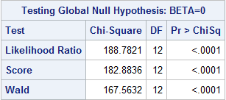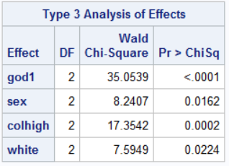
2. The Odds Ratio Estimates (presented on the next page) explain the extent to which each variable contributes to the response variable. In general, odds ratios above 1 indicate a leaning towards science being funded too much, and below 1 indicate a leaning towards science being funded too little. The numbers in the natsci1 column correspond to the level of the science spending. 1 represents “just right”, and 2 represents “too much”. These odds ratios are all compared to level 0 (“too little”). Notice that as the the response changes from 1 to 2, the effect (point estimate) changes as well. This would not be the case with a cumulative logit model, which follows the proportional odds assumption.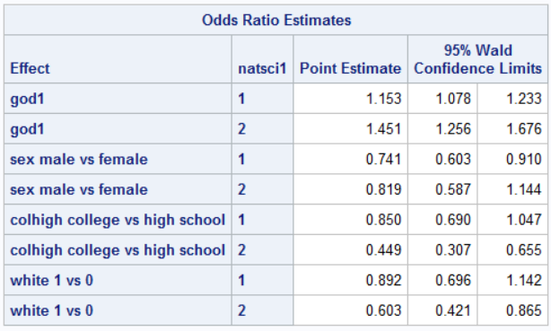

In order to understand these odds ratios, we will focus on the God variable first. Consider two random individuals in the United States, one of them has a slightly stronger belief in God (see the description of the god variable under variables simplified). The odds that the respondent with the higher belief in God thinks that we spend just the right amount (1) on science vs too little (0) is between 7.8% to 23.3% higher. Similarly, the odds that the individual with the slightly stronger belief in God thinks that we spend too much (2) on science vs too little (0) is between 25.6% to 91.0% higher than the respondent who believes in God to a lesser degree. Simply put, a higher belief in God results in a person leaning more toward science gets too much funding. This is true while holding sex, degree, and race constant. Looking at the other variables, we can see that males have a lower odds of choosing “just right” than “too little” funding for science while holding all other variables constant. It is interesting to see that there is not a significant difference in odds for males and females when comparing “too little” to “too much.” We can see this from the 95% confidence interval for the odds being from 0.587 to 1.144. Because 1 is included within the given range, it is within reason to have the odds be about the same for men and women between thinking spending is too much compared to too little for science. Similarly, we can also see that individuals with at least some college education have a higher odds of leaning toward science is underfunded while holding the other variables constant. Lastly, white people have higher odds of science being underfunded vs. overfunded. A summary of this information can be found in the table below.

|  |  |  |
| --- | --- | --- |
| Variable | Thinking “just right” compared to “too little” on funding for science | Thinking “too much” compared to “too little” on funding for science |
| Higher belief in God | Higher odds | Higher odds |
| Male | Lower odds | No significant difference |
| Some college | Lower odds | Lower odds |
| White | No significant difference | Lower odds |

#### Space Exploration Model

Similar to the previous model, the proportional odds assumption failed, so we used the Baseline-Categorical model and treated the funding for space research variable as nominal.

1. First we must test the Global null hypothesis: BETA = 0. If the p-values are too large, then none of the variables have any significant predictive power. From the table below, we can see that this model does explain some variation.
2. Next we can look at the individual variables and their significance in the model using the Type 3 Analysis of Effects. We can see that each variable is significant given all of the other variables in the model. 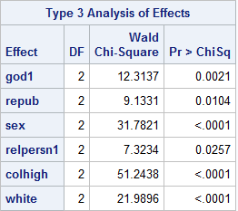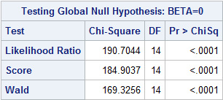
3. The odds ratios for each variable are shown below. The column “natspace1” represents the Space Research funding response variable, which is being compared to “too little” spending. The rows with 1s are comparing “just right” to “too little” spending and the rows with 2s are comparing “too much” to “too little” spending on space exploration.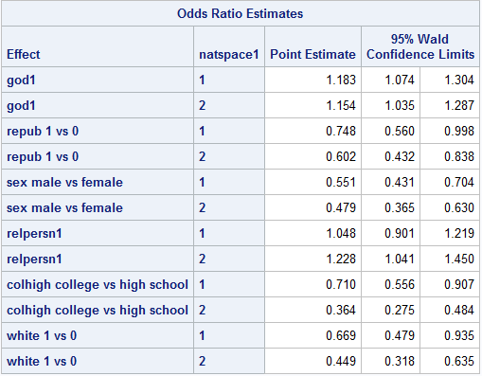

Again, we see in this model that the higher belief in God results in higher odds of “just right,” and “too much” spending when compared to “too little” spending. Males have lower odds of thinking space exploration is funded “just right” or “too much” when compared to “too little.” The college educated and white individuals have lower odds of “just right” or “too much” when compared to “too little” spending. The variables that did not appear in the last model but did in this model are Republican indicator (repub), and religiosity (repersn1). Similar to the God variable, as the level of religiosity of a person increases, there are higher odds of thinking space research gets funded “too much” compared to “too little.” There is no significant difference in odds between “too much” funding and “just right” funding when religiosity is increased. Probably one of the more interesting finds in this model is that Republicans have lower odds of thinking space is funding “just right” or “too much” compared to “too little”. In other words, Republicans have higher odds of thinking space exploration research is underfunded. The summary of these odds are shown in the table below.

|  |  |  |
| --- | --- | --- |
| Variable | Thinking “just right” compared to “too little” on funding for space research | Thinking “too much” compared to “too little” on funding for space research |
| Higher belief in God | Higher odds | Higher odds |
| Republican | Lower odds | Lower odds |
| Male | Lower odds | Lower odds |
| Higher religiosity | No significant difference | Higher odds |
| Some college | Lower odds | Lower odds |
| White | Lower odds | Lower odds |

### Environment Improvement and Protection model

In this last model, the cumulative logit model is used and all assumptions are met.

1. First we will test the Global null hypothesis: BETA = 0. If the p-values are too large, then none of the variables have any significant predictive power. From the table below, we can see that this model does explain some variation. 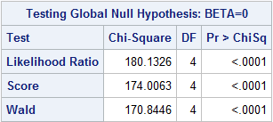
2. Next is the Type 3 Analysis of Effect to check the individual significance of each variable within the model. We can see from the table below that each of the variables are significant. 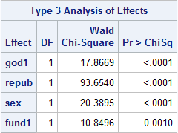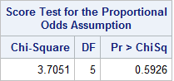
3. In order to treat the response variable as ordinal, the proportional odds assumption is required. The test for proportional odds output shows whether the model is consistent with this assumption or not. From the table below, we can see that this assumption is consistent with our model.

4. The odds ratios for each of the predictor variables is shown below.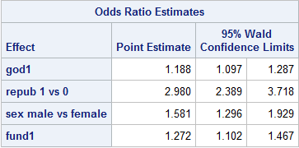

For each of these odds ratios, the comparison is between increasing a level of the predictor compared to an increase in level of the response. In other words, as belief in God increases by 1, the odds of being more toward “too much” spending is between 9.7% and 28.7% higher. Again, a higher belief in God results in higher odds of thinking there is too much spending. Republicans have about 200% higher odds of thinking the environmental protection and improvement spending is too high. Males think similarly but to a lesser extent, and the more fundamental a person considers himself or herself towards their religion, the higher the odds of leaning toward thinking environmental spending is too high. The summary of the odds are in the table below.

|  |  |
| --- | --- |
| Variable | Leaning toward “too much” funding for Environmental protection |
| Higher belief in God | Higher odds |
| Republican | Higher odds |
| Male | Higher odds |
| More fundamental | Higher odds |

#### Notes about variables in models

Within the race variable, “other” and “black” were insignificant in the model given that the other was made the baseline, while “white” was always significant. We added “black” into “other,” and left “other” as the baseline to compare against “white.” The education variable was collapsed into two variables; is the respondent's highest grade level less than or equal to high school was the baseline, while greater than high school was the alternative. Political party was collapsed into two variables as well, since Independent and Democrat were insignificant when either was the baseline. They were combined into a “Non-Republican” variable and was thus used as the baseline.

Party, race, interest in space, interest in science, interest in environment, prayer per day, belief in God, and degree of fundamentalism were all recorded to be numeric, and treated as an ordinal variable in the models when possible. See the variable codes in the appendix.

## Results, conclusions, and recommendations

Modeling the different science spending opinion variables, there were several similarities and a couple surprises. For scientific research spending, space research spending, and environmental protection and improvement spending, a higher belief in God resulted in a higher odds of leaning toward “too much” spending. College educated individuals and white individuals have higher odds of thinking space and science are not funded enough. A more religious person (not the same as level of belief in God), tends to have higher odds of thinking that space research is overfunded compared to underfunded, while a more fundamentalist individual has higher odds of thinking that environmental protection and improvement spending is too high.

One of the surprising results appeared with the Republican opinion. Republicans have about the same opinion on scientific research spending, but changing opinions when it comes to space exploration and environmental spending. Republicans have somewhat higher odds of thinking that space research is underfunded, but much higher odds of thinking environmental protection spending is too high. Males similarly have higher odds of thinking space research is underfunded and environmental protection is funded to high, but something interesting happened with scientific research spending. When comparing “too little” spending to “just right” amount of spending, males had higher odds of choosing too little. However, when comparing “too little” to “too much” spending there was no significant difference. This of course is a result while holding belief in God, race, and degree constant, but it seems to suggest that men have higher odds of choosing the extreme values compared to women. Unfortunately the trend does not continue when comparing “just right” to “too much” spending; There is no significant difference for males and females for these two levels.

It seems overall that religious people have higher odds of thinking that all science is over funded, and men and college educated people have a higher odds of thinking science and space is underfunded. Men and republicans change their minds between space exploration research and environmental protection for some reason.

There were several areas that could use some extra study. This project only covered demographic variables and religious related variables from 2014. There are many other types of variables that can easily be downloaded from with the GSS data that this project did not cover, and although 2014 is the most recent year, there may be some trend over time that can be taken into account from the previous years. The type of variables considered as an option for this project, but not used were altruistic measurements, income level, and job prestige.

Some of the variables used in this project were simplified to fewer groups and one variable may need expansion. There are many races in America and the GSS race variable only includes white, black, or other. 347 of the 3842 participants identified as other, which could possibly hold information not previously seen. In any project of this type, there are many different options and combination of variables that can be used to predict any of the three science spending variables. We assumed for this project that public opinion on science spending translates to policy for science spending in the government. This assumption seems valid, but it may be good to also assess the voting patterns along with public opinion to more accurately predict policy.

## 

## 

# Appendix

1. https://www.nasa.gov/50th/50th_magazine/benefits.html

Dunbar, B. (2008). Retrieved December 02, 2016, from https://www.nasa.gov/50th/50th_magazine/benefits.html

2. https://spinoff.nasa.gov/Spinoff2008/tech_benefits.html

(n.d.). Retrieved December 02, 2016, from https://spinoff.nasa.gov/Spinoff2008/tech_benefits.html

3. https://www.epa.gov/climatechange/climate-change-basic-information#Change

Climate Change: Basic Information. (n.d.). Retrieved December 02, 2016, from https://www.epa.gov/climatechange/climate-change-basic-information

4. http://www.21stcentech.com/money-spent-nasa-waste/

H. (2014). No One Should Think That Money Spent on NASA is a Waste. Retrieved December 02, 2016, from http://www.21stcentech.com/money-spent-nasa-waste/

5. http://www.huffingtonpost.com/lauren-lyons/misconceptions-nasa_b_3561205.html

Lyons, L. (n.d.). 5 Popular Misconceptions About NASA. Retrieved December 02, 2016, from http://www.huffingtonpost.com/lauren-lyons/misconceptions-nasa_b_3561205.html

6. https://www.opr.ca.gov/s_listoforganizations.php (CA OPR, 2011)

7. http://climate.nasa.gov/scientific-consensus/ (NASA, climate change consensus, 2016)

(n.d.). Retrieved December 02, 2016, from http://climate.nasa.gov/scientific-consensus

8. http://climate.nasa.gov/evidence/ (NASA, climate change evidence, 2016)

(n.d.). Retrieved December 02, 2016, from http://climate.nasa.gov/evidence/

9. https://en.wikipedia.org/wiki/Budget_of_NASA (Nasa Budget

Budget of NASA. (n.d.). Retrieved December 02, 2016, from https://en.wikipedia.org/wiki/Budget_of_NASA

10. GSS Data Explorer | NORC at the University of Chicago. (n.d.). Retrieved December 04, 2016, from https://gssdataexplorer.norc.org/variables/vfilter

11. EPA's Budget and Spending. (n.d.). Retrieved December 05, 2016, from https://www.epa.gov/planandbudget/budget

12. Trump Says He Has 'Open Mind' On Climate, But Staff Pick Raises Questions. (n.d.). Retrieved December 05, 2016, from http://www.npr.org/sections/thetwo-way/2016/11/23/503156456/trump-says-he-has-open-mind-on-climate-but-staff-pick-raises-questions

13. Milman, O. (2016). Trump to scrap Nasa climate research in crackdown on 'politicized science' Retrieved December 05, 2016, from https://www.theguardian.com/environment/2016/nov/22/nasa-earth-donald-trump-eliminate-climate-change-research

## Variables

|  |  |  |
| --- | --- | --- |
| Variable Name | Name in data | Values |
| Scientific Research | natsci1 | 0, 1, 2 |
| Space Exploration | natspace1 | 0, 1, 2 |
| Environmental Improvement and Protection | natenvirn1 | 0, 1, 2 |
| Region of interview | region | 9 different options which can be found on the GSS website |
| Political party | partyid1 | 0, 1 |
| age | age | Numeric values from 18 to 89 |
| Highest degree | colhigh1 | 0, 1 |
| sex | sex | “female”, “male” |
| race | white | 0, 1 |
| Level of religiosity | relpersn1 | 0, 1, 2, 3 |
| Amount of Prayer | pray1 | 0, 1, 2, 3, 4, 5 |
| Level of Belief in God | god1 | 0, 1, 2, 3, 4, 5 |
| Religion of respondent | relig | 13 different choices can be found on GSS website |
| Degree of Fundamentalism | fund1 | 0, 1, 2 |

## SAS Code

**proc** **logistic** data = proj;

class relig(ref = 'none') colhigh(ref = 'high school') repub(ref = '0')

sex(ref = 'female') white(ref = '0') region(ref = 'pacific')

/param = ref;

model natsci1(ref='0') = relig god1 repub sex relpersn1 colhigh white region

pray1 fund1 / link = glogit selection = backward;

output out = prob predprob = i;

**run**;**quit**;

**proc** **logistic** data = proj;

class relig(ref = 'none') colhigh(ref = 'high school') repub(ref = '0')

sex(ref = 'female') white(ref = '0') region(ref = 'pacific')

/param = ref;

model natspace1 = relig god1 repub sex relpersn1 colhigh white region

pray1 fund1 / link = glogit selection = backward;

output out = prob predprob = i;

**run**;**quit**;

**proc** **logistic** data = proj;

class relig(ref = 'none') colhigh(ref = 'high school') repub(ref = '0')

sex(ref = 'female') white(ref = '0') region(ref = 'pacific')

/param = ref;

model natenvirn1(descending) = relig god1 repub sex relpersn1 colhigh white

region pray1 fund1 / link = clogit selection = backward;

output out = prob predprob = i;

**run**;**quit**;